Steps for a USA Notary to Create and Complete
a RON/eNotary Transaction
*** All text in green only applies to In-Person E-Notarizations***
Document Preparation:
- After logging into the Document Center Home screen, the notary will select “Create New Transaction” in the upper right corner.
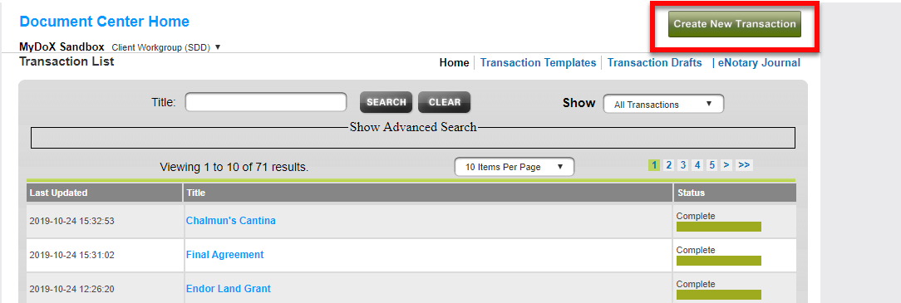
- For a notarization with 1 signer and 1 notary, the notary will enter in the client’s info first, providing first name, last name, and email address. If the eNotary transaction will be done remotely, under the Authentication tab select “Knowledge-Based Authentication (KBA) w/ID Verification.” Then check the “Ask the Signer” checkbox when it asks for SSN and DOB. [NOTE 1] Then click “Add Signer.”
NOTE 1: If the transaction will be done in-person with physical identity credentials shown to the notary, select “Email Only.”
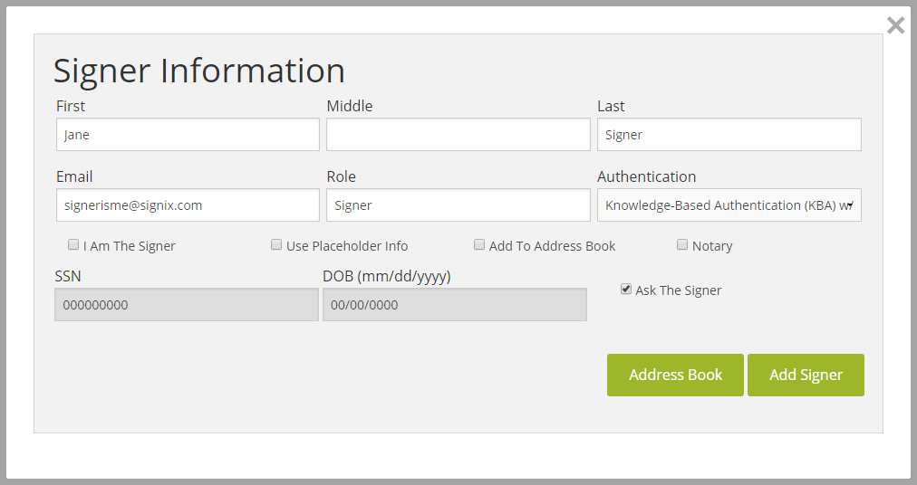
- If any additional parties (other than the Notary) need to be added to the transaction, select “Add New Signer” and repeat step 2.
- To add the notary (yourself) as a signer, select “Add New Signer” on the left side, and this time simply select “I am the Signer” to have your first name, last name, and email address automatically entered. Authentication should be left on the default option, “Email Only.” Next, check the “Notary” box then add the additional required information and upload your notary seal. This information will be saved for future transactions, and you won’t need to re-enter the information. IMPORTANT!!! Do NOT edit your name or email address after clicking I am the Signer as it may result in ejournal errors. If the name that is displayed is not what you would want reproduced on the document, please contact SIGNiX Support to change it. Then click “Add Signer.”
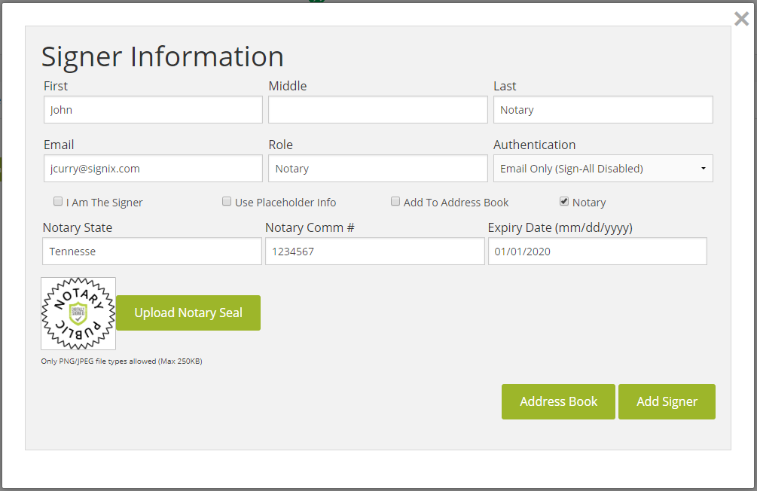
- Once all parties have been added, click “Next” at the bottom of the screen or select the “Documents” tab at the top of the screen to advance to the next step.
- Select “Upload a Document” and choose a PDF document on your computer to upload. There is a 10MB max file size per document. Repeat this process for any additional documents required within this transaction. There is no limit on the number of documents you may upload.
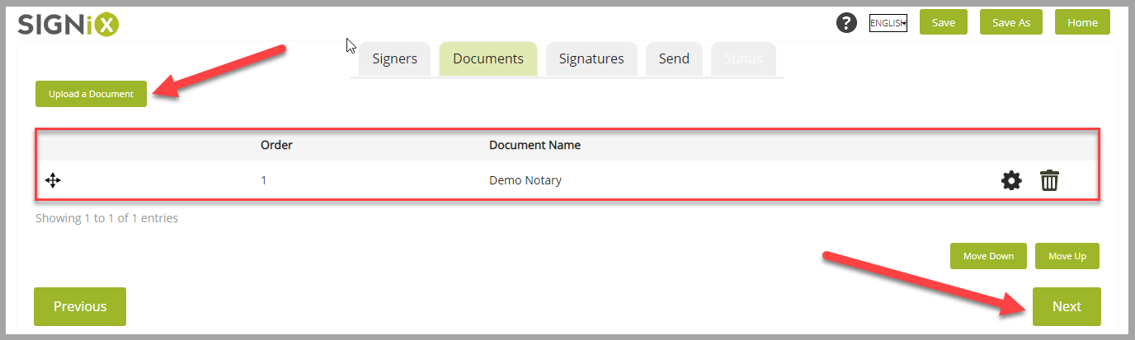
- Click “Next” at the bottom of the screen or select the “Signatures” tab at the top of the screen to advance to the next step.
- Next, you will add tasks (also known as tags or fields) for the signers and yourself to perform on the document(s) you have just uploaded. To add these tasks, first scroll down the document to where signatures, dates, initials, checkboxes, etc. need to be placed on the page. Drag and drop the required task from the tool bar on the left side of the screen onto the document. These task fields can be repositioned, resized or deleted. When finished assigning tasks for one person, select the next party in the drop-down menu titled “Signers” at the top of the page. Repeat this process for every signer. Each time a notary’s signature is placed on the document, you can also add a corresponding seal from the tool bar.
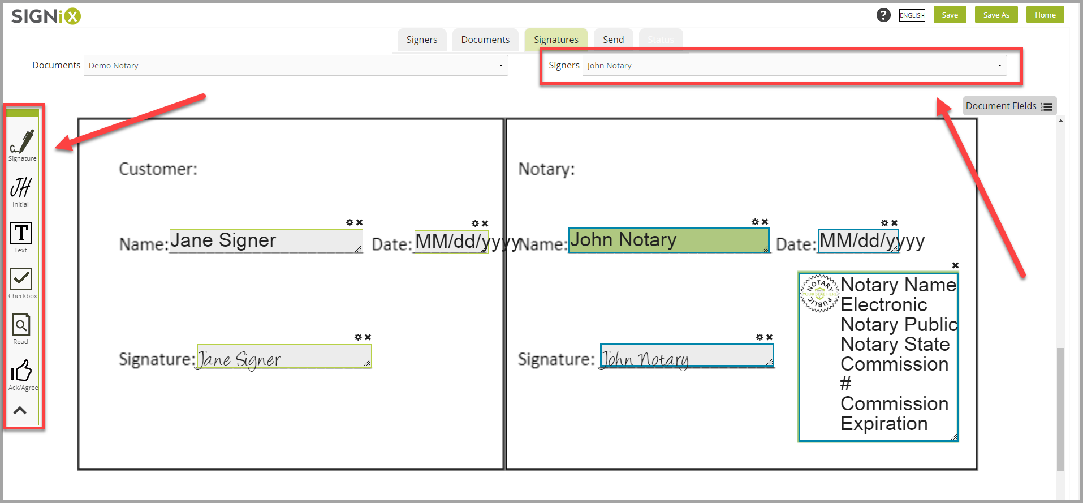
- Click “Next” button at the very bottom of the screen, using the outer most scroll bar, or select the “Send” tab at the very top of the screen to advance to the next step.
- Edit the Transaction Title [NOTE 2] and Email Message [NOTE 3] as desired, to help the signers understand what they have been sent to sign. You may use the slider at the bottom left side of the screen to choose the reminder and expiration timing, keeping in mind that it should not expire before the scheduled time to conduct the notarization. You may also leave the slider where it is by default.
NOTE 2: SIGNiX recommends that a unique title be given for each transaction as this name is reflected in the eNotary Journal and communications sent regarding this transaction. i.e. Jane Signer – Bank Loan.
NOTE 3: You may also customize your email message to inform the signer not to sign the document until they are in the scheduled online meeting (if remote) or they are in-person with you.
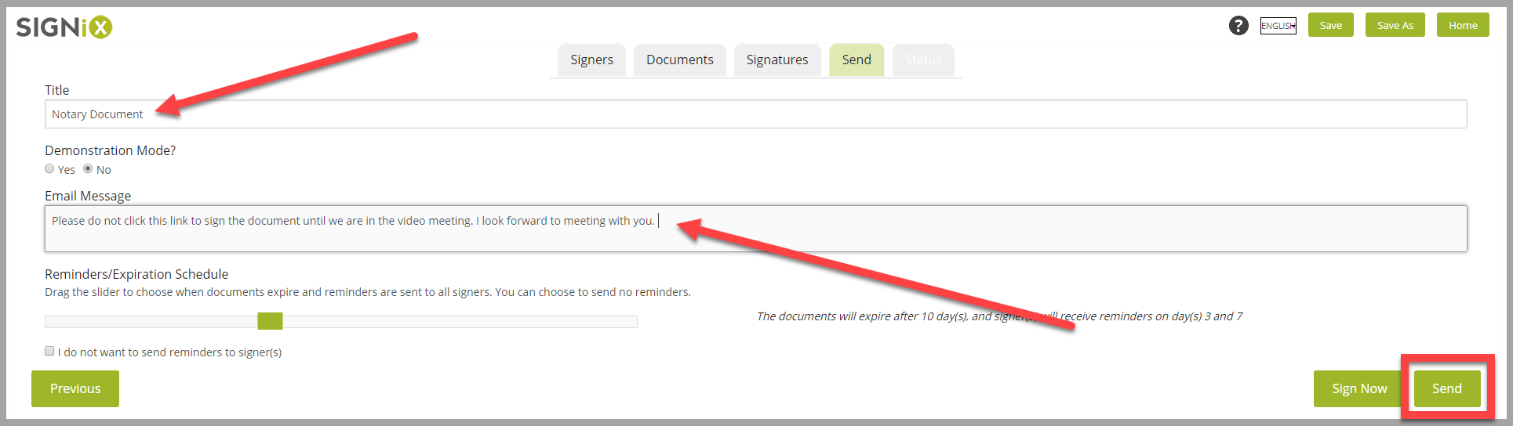
- Click “Send” at the bottom right side of the screen to start the transaction and send an email to the first signer. This first email will include a link which the signer can click on to access and sign the documents. Signers do not need to use the link until they are in the video meeting with you, so that signing can take place with you ready to witness it.
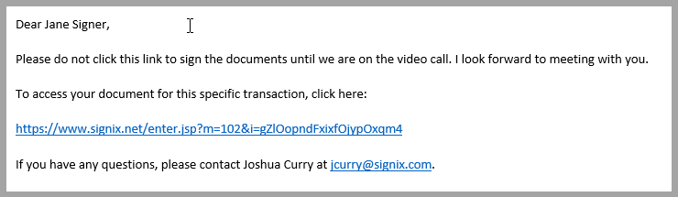
- After the transaction has been sent and started, a “Start Zoom Meeting” box will appear where you can “Schedule” a time for the online video meeting. Or if you are meeting right away, you can select “Launch Now” to start Zoom immediately. [NOTE 4] Both of these options will send an email notification to all parties with a link to join the meeting. This means that the first signer on the transaction will receive two emails, the first to access and sign the documents, and the second to join the Zoom meeting. [NOTE 5]
NOTE 4: Only 1 video meeting is allowed per each transaction. If a transaction is not completed before the meeting is ended by the notary, then a new transaction must be created, and you will start over with step 1 again.
NOTE 5: If the notarization will be done in-person, choose the “Not Right Now” and then “In-person” buttons instead.
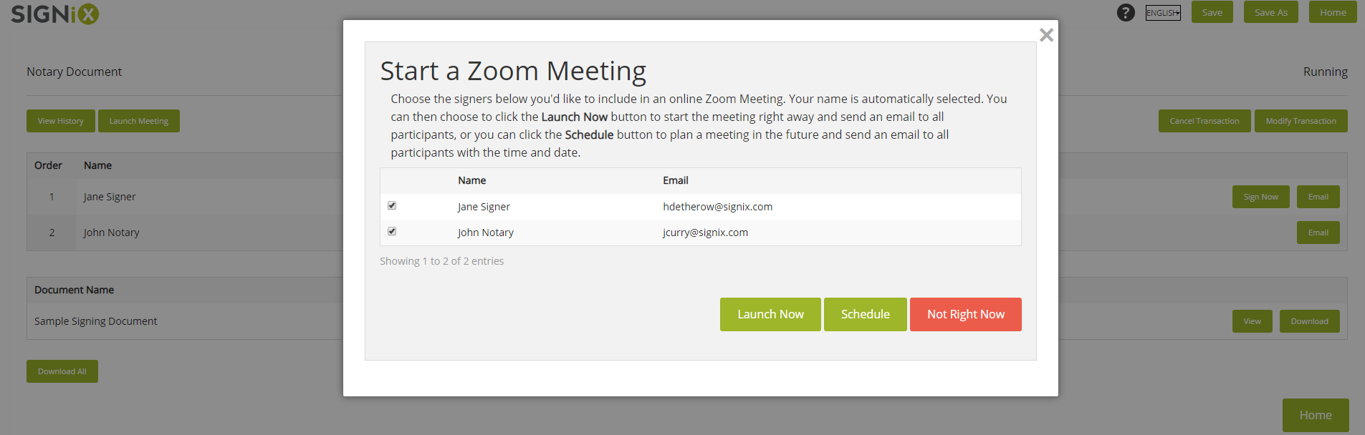
- Make sure to “Logout” once you have sent out the invite to the Zoom meeting. Failure to do so may result in locking you out of the platform or corrupting the documents.
Client Meeting:
- The Zoom meeting can be started by either using the link in the meeting email, or by clicking “Start” under the “Meeting Information” section on the transaction “Status” screen. We recommend that new notaries join their first meeting a few minutes early to ensure time to download the Zoom application. The meeting will be automatically recorded, but the recording may be paused or stopped if necessary.

For remote notarizations, state laws require these meetings to be recorded.
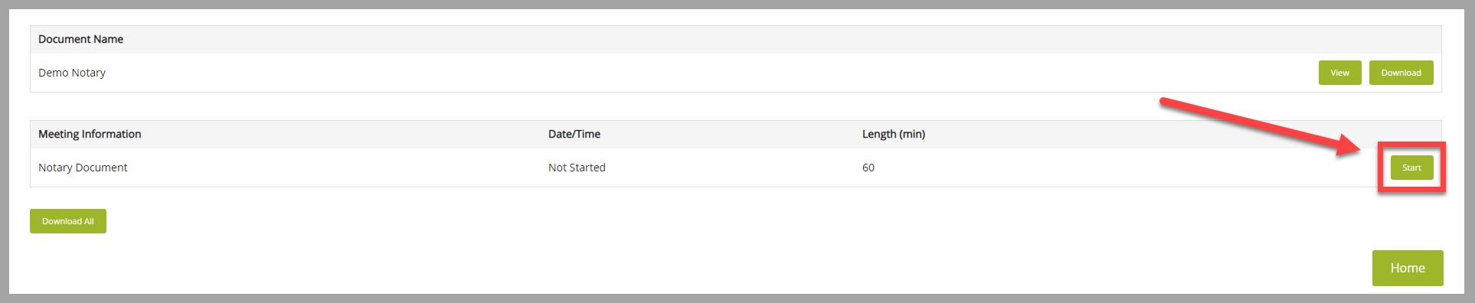
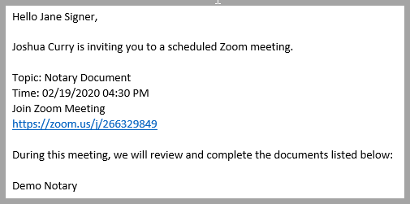
- To start the video, ensure a webcam is connected to your computer. At the bottom left side of the Zoom application, there will be a “Start Video” button. The signer(s) must also have a working webcam or smart phone camera for the transaction to be legal.

If they are unable to get their camera working, the notary should not proceed.
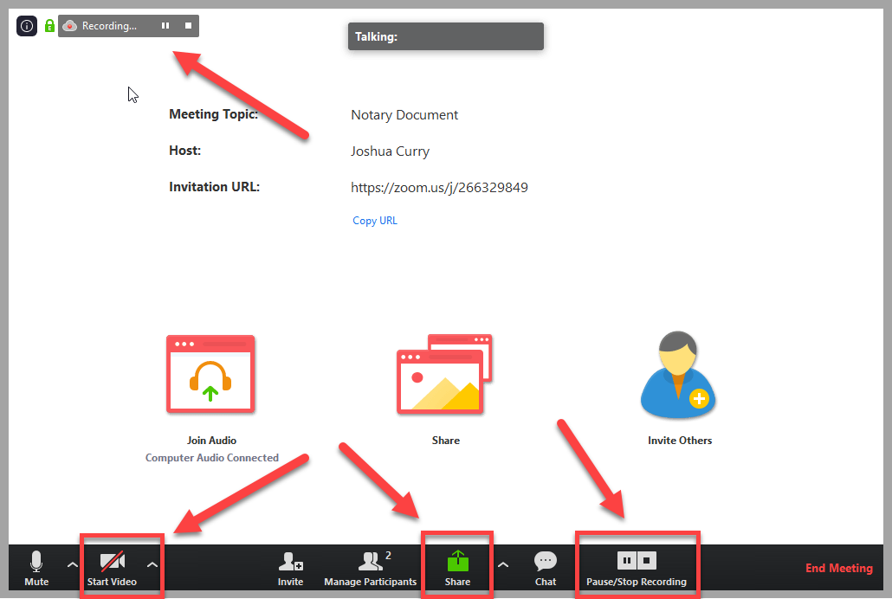
- A typical conversation should include the following:
  - You should provide your name, location, date, and purpose of video call.
Example: Good morning, my name is John Smith and I am a commissioned notary for the commonwealth of Virginia. Today is May 29th and I’m in my office in Richmond. I will take the acknowledgment of your signature on a (power of attorney) document, is that correct?
  - Let your signer know that the video call is recorded and that there will be a variety of steps to authenticate who they are.
Example: I want to let you know that this call is recorded and that we will go through a few steps to verify your identity.
  - You should have the signer provide their name and current residential address.
Example: Could you please state your name and current residential address for the record?
- When the signer clicks on the link in their email for signing the documents, they will reach the login screen. During login, they will accept legal consent to use e-signature before entering their SSN and DOB, then they must complete the multiple-choice Knowledge-Based Authentication (KBA) questions before they share their screen.

The KBA questions will contain personal information that should not be shared or recorded, so please make sure your signer moves past this login step before choosing to share their screen with you in the Zoom meeting.
If they cannot pass the KBA questions with correct answers after 2 attempts, they will be unable to continue with the remote online notarization at that time. We recommend ending the meeting and discussing how the signer would like to proceed.
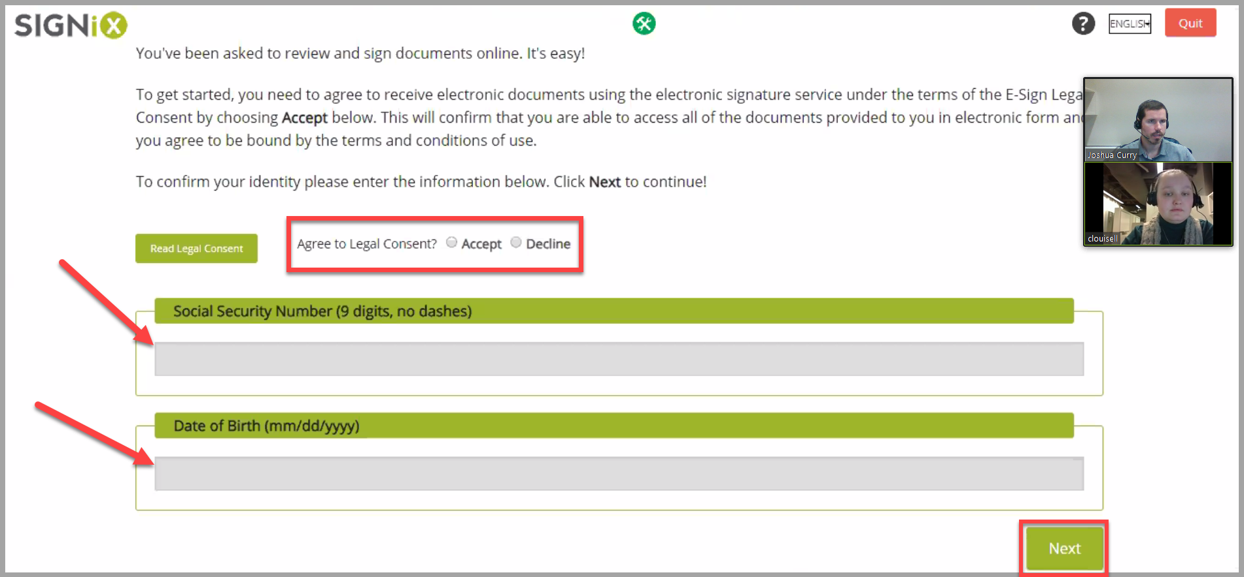

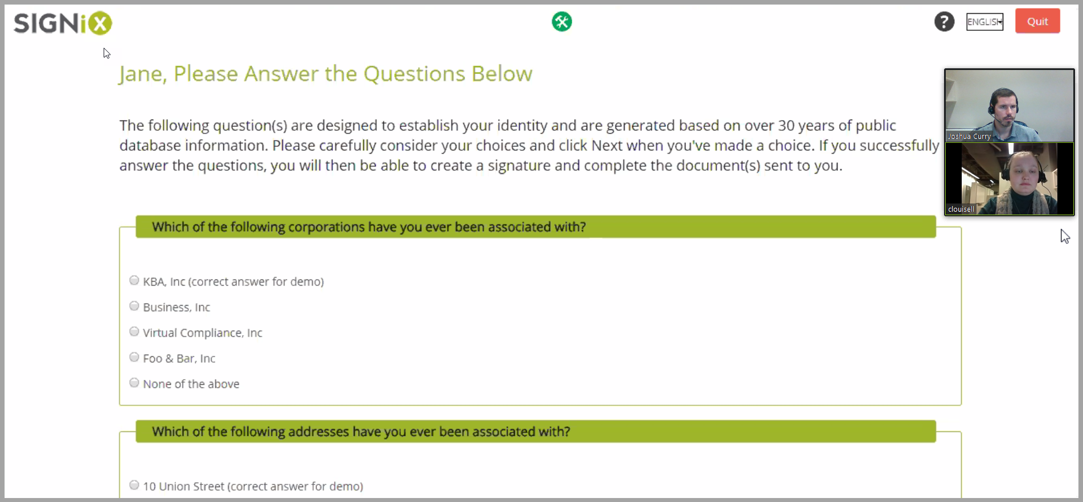
(You should not view the screens above, but they are displayed here for reference)
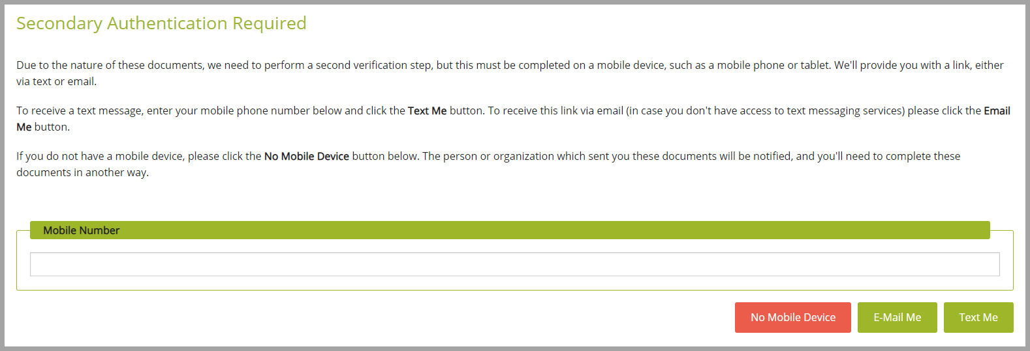
- Next your client will be brought to a page to have the next step either emailed or texted to them. The link which is either emailed or texted must be opened on a mobile device. They will want to leave this screen up, and not close it out, while performing the next step.

- When the client clicks the link on their phone it will open a browser to take pictures of their ID, and a selfie of themselves. See images below. Once complete, they will be directed back to the original page they answered their KBA questions on, which should still be open and waiting for them.
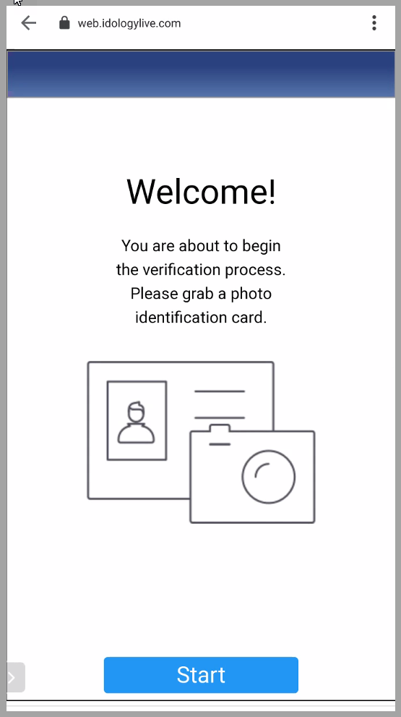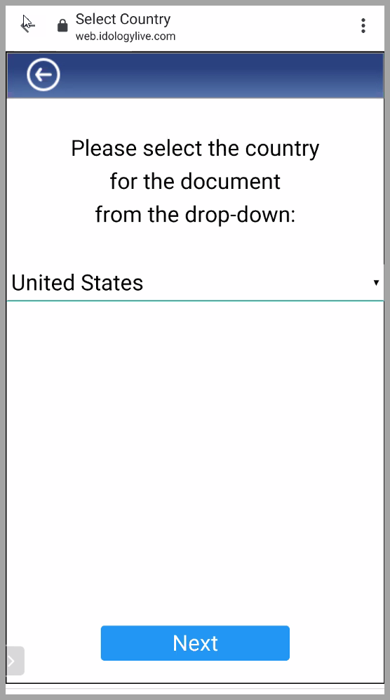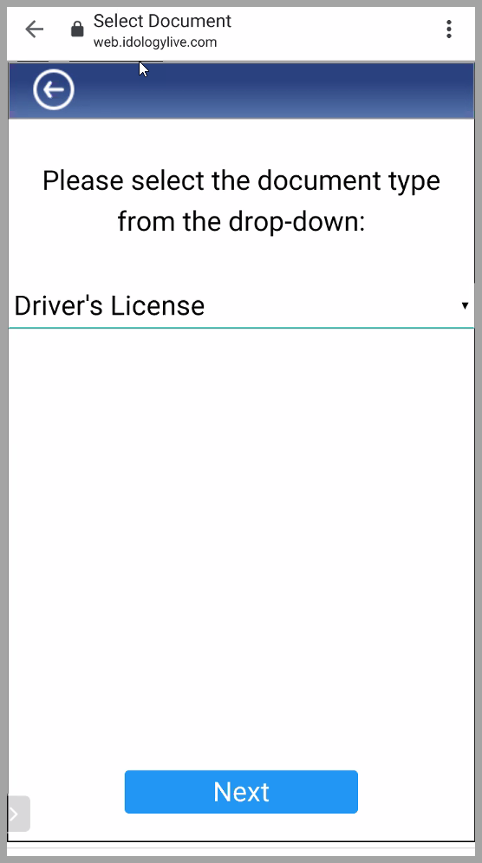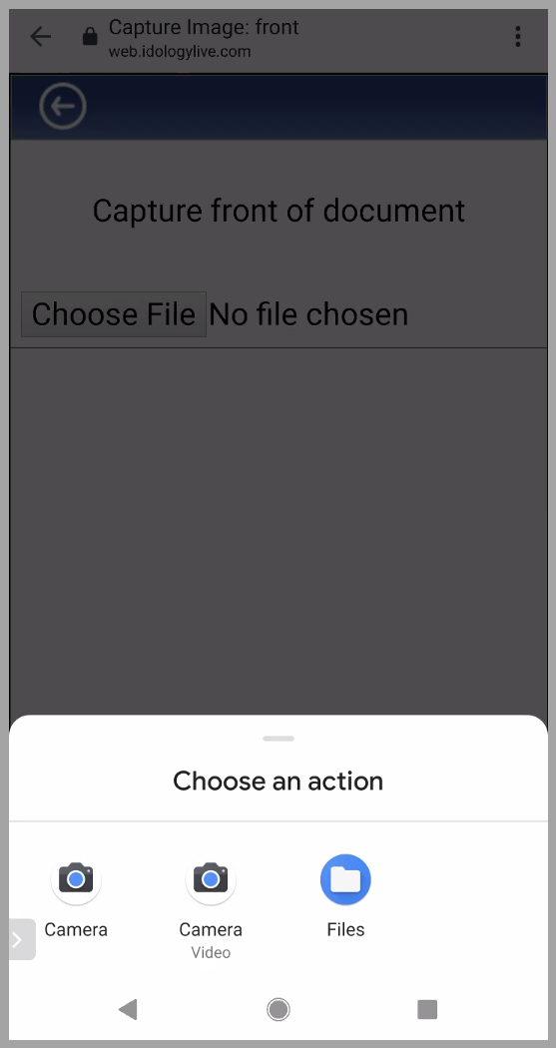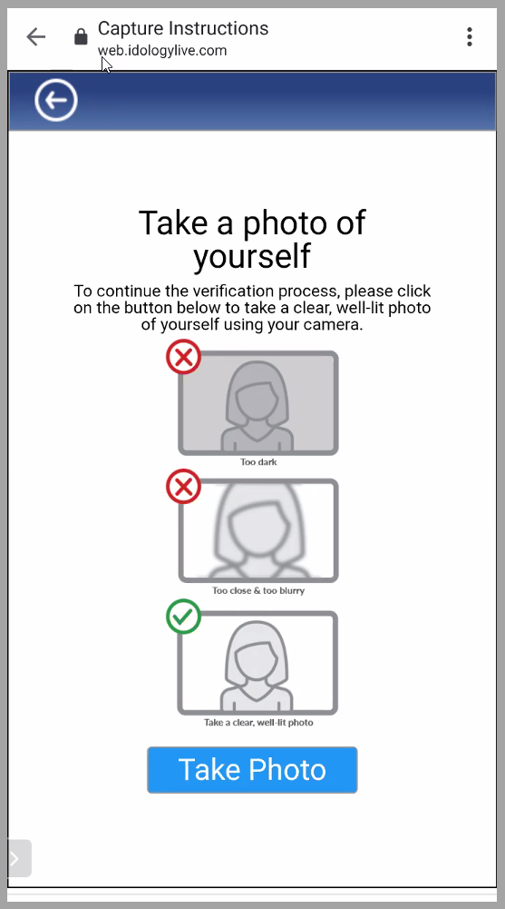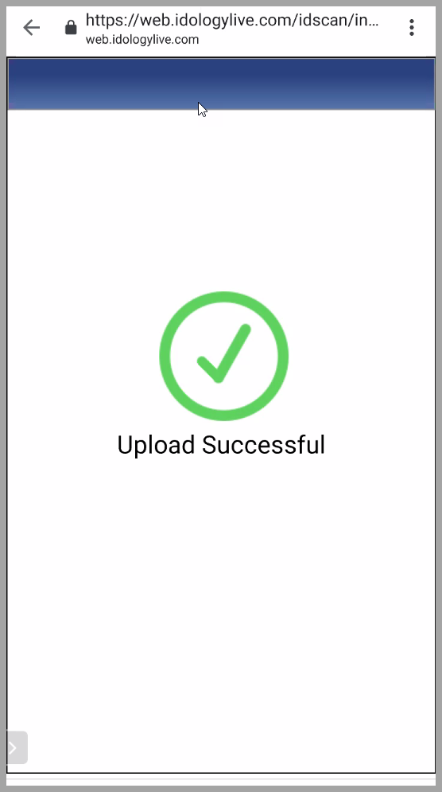
- Once the signer has answered the KBA questions successfully and completed the credential analysis on their mobile device, they can then share their screen with you in the Zoom meeting [NOTE 6]. The signer will click the green “Share” icon found at the bottom of the Zoom application in order to share their screen with you.
NOTE 6: Confirm with your client they have completed the KBA questions prior to sharing their screen
- Next, the signer will need to set up a password. They will use this password in the future both to login and sign documents, and to review previously signed documents. They can also choose a font they would like their signature to use in appearance.
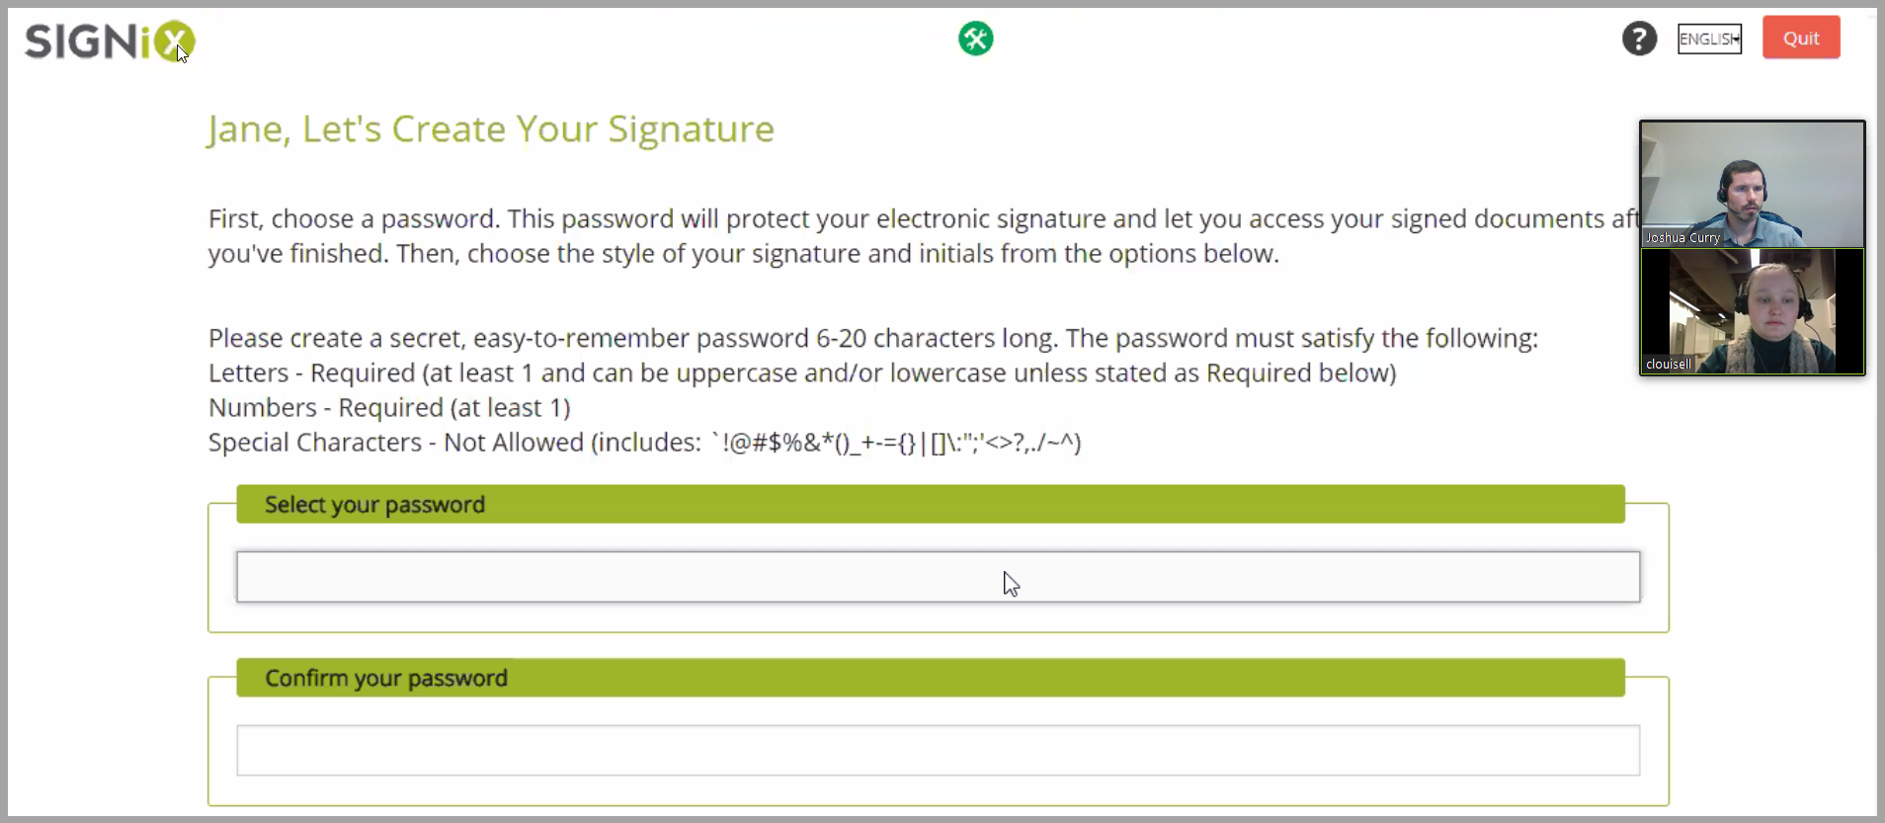
- When brought to the document, the signer can select “Go” or “Let Me Review” on the “Ready to Review and Sign?” screen. We recommend the signer click “Go” in order to automatically move to the first mandatory task on the document. The signer will then click on the “Sign” or “Initial” flags [NOTE 7] on each task in order to place their signature or initials in the indicated places. The system will automatically prompt them to finish after they have completed all tasks assigned to them.
NOTE 7: The signer must click on the word “Sign” and not just click somewhere inside the signature task field. The signature will only appear on the screen once the word “Sign” has been clicked.

It is important for the signer to be sharing their screen before beginning this process.

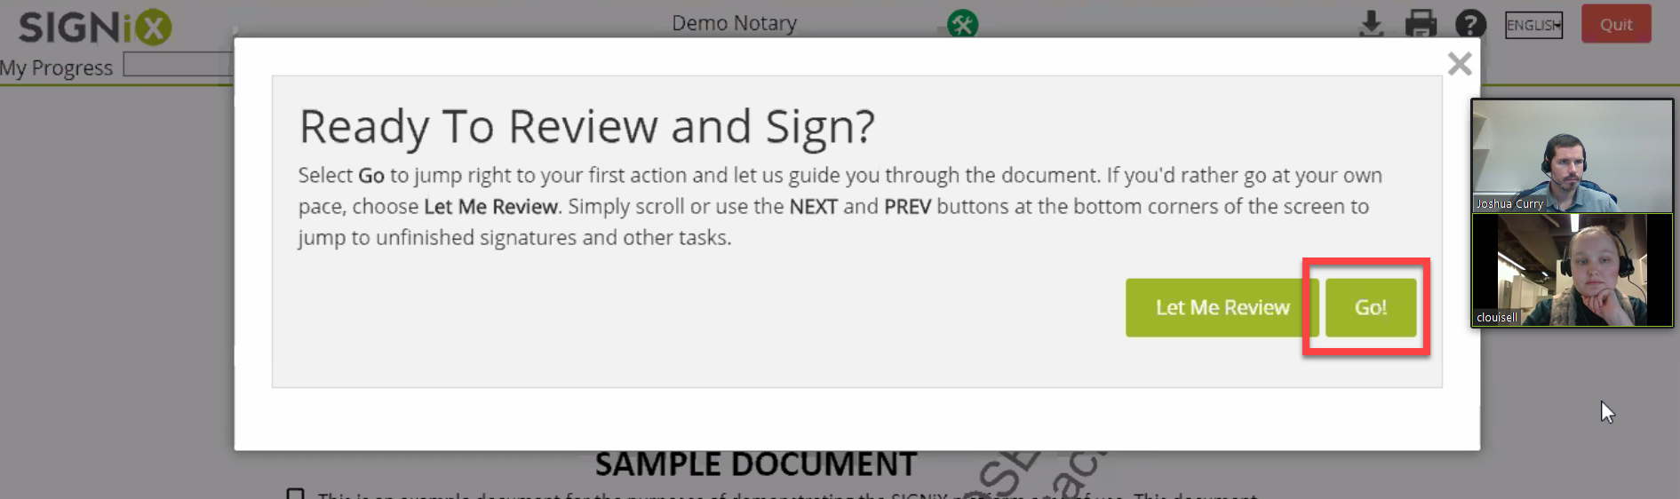

- Once the client selects “Finish” in the previous step, the notary will then receive an email with a link to sign exactly like the first signer’s email. The notary must use this link to login as a signer.
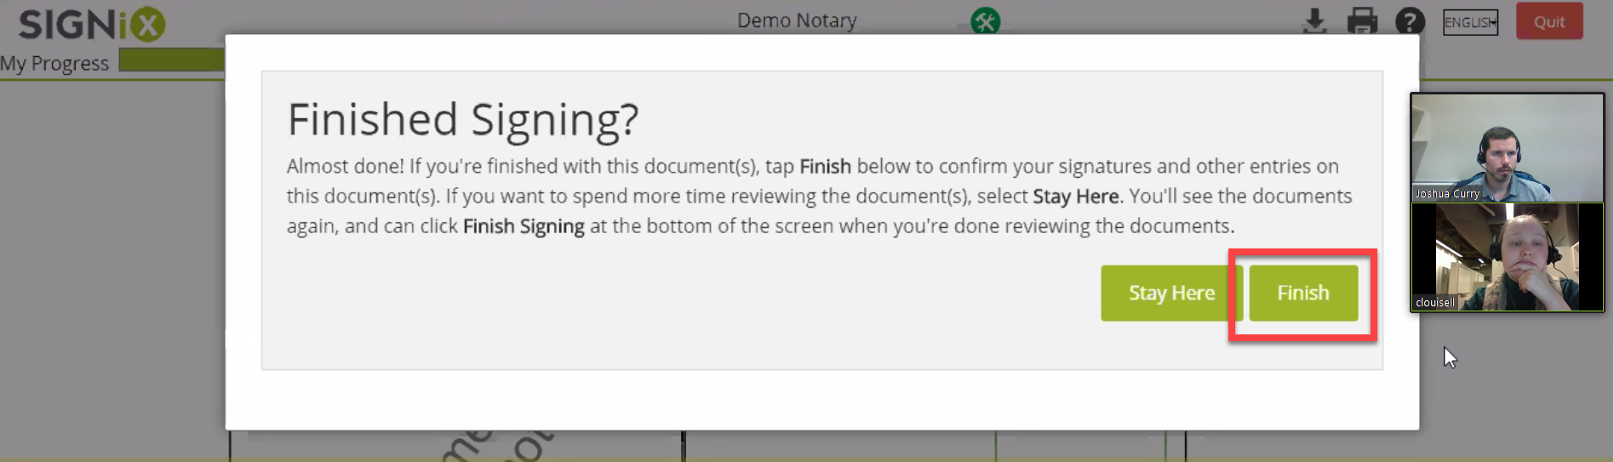
- After logging in with their password, the notary will then share their screen and the first step you will need to complete will be to compare the ID on the screen to your client’s webcam image. If you believe that is the same person, you’ll select “Pass” to continue, otherwise you’ll select “Fail” to terminate the transaction.
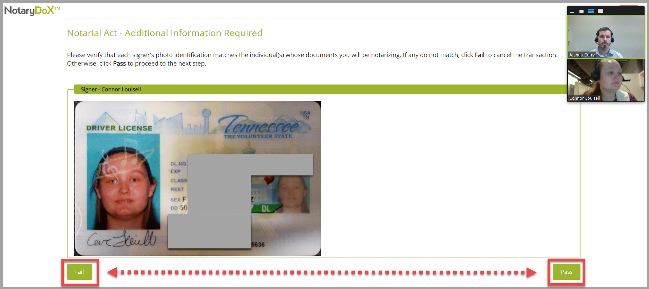
- Complete the Notarial Act page requiring additional information which will be recorded in the eNotary journal. If you are in a remote session, be sure to choose “Remote – KBA w/ID” in the “ID Method” field and enter N/A in the “Misc” box.

If you are handling this in-person, be sure to choose the ID Method being used with your clients and enter the ID information in the “Misc” box.
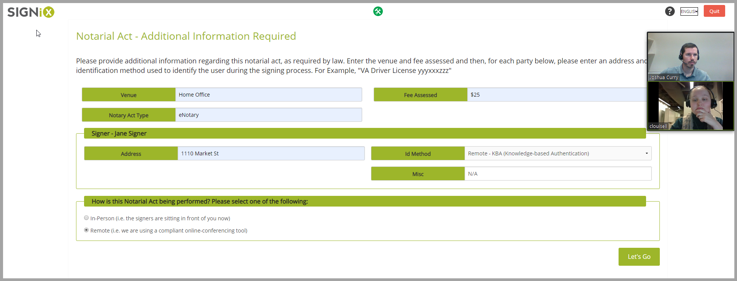
- The notary will then go through the signing process in the same way, sharing their screen before notarizing the document. They will confirm with all signers that the signatures are theirs:
Example: Do you acknowledge the signature that appears here to be yours? And was it given of your free act and deed?
- Once complete, the notary will select “Finished Signing.” [NOTE 8] The notary may then review the completed document with the client, showing both signatures and the seal(s) by clicking “Review” on the “Thanks For Signing Online!” page. This completed document can also be viewed from the email link that will be sent to all parties after the transaction has been fully completed.
NOTE 8: Notary seals will not appear during the signing process, but will appear after signing when viewing the completed document.
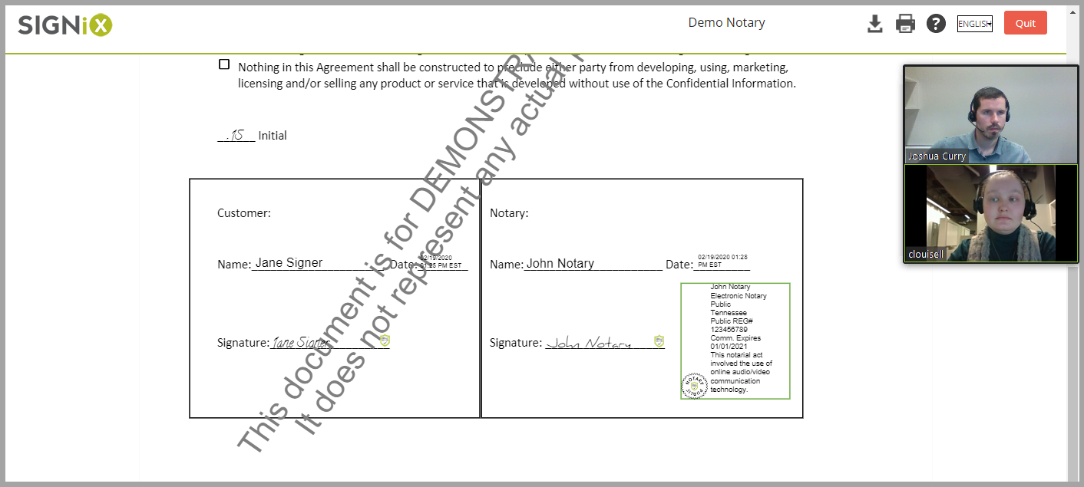
- When concluding the video meeting, the notary should inform the signers that they will receive an email about the transaction being complete, with a link for them to re-access the document to view / download. There is a button at the top of the Review screen, shown in the above image, that looks like a down arrow, and this button is how your signers may download the completed document onto their computer to store for themselves. Then the notary can click on “End Meeting” to terminate the Zoom meeting once all questions have been answered.

Post-Meeting:
- Log back into the notary’s Document Center Home screen and select the now completed transaction.
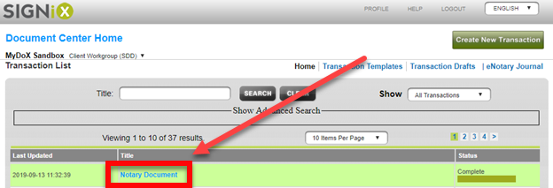

- Select “Download All” to download the signed PDF document and the Audit Trail as a zipped folder [NOTE 9]. Then download the video meeting under the “Meeting Information” section of the “Status” screen.
Note that it may take several minutes for the video to become available for download.
NOTE 9: “Download All” will NOT include the video recording. This must be downloaded separately.
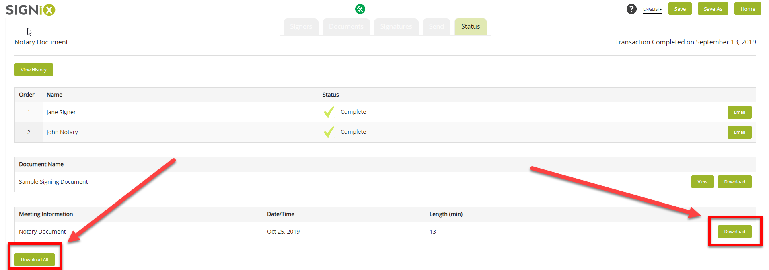

- To download a current copy of the eNotary Journal from the Document Center Home screen, select “eNotary Journal” in the upper right corner, seen in the image below. This will download a PDF version of the journal for all completed eNotary transactions performed so far.
